I’m getting an ‘Error Loading Layer File’ message when I try and open Spatial View

For some reason a few users are getting these errors when trying to load spatial view.
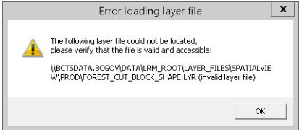

The layer files being reference in the error messages do exist but this has something to do with the user’s profile. To fix this complete the following steps:
- Close Spatial View via the File menu within the Spatial View window (File – Close Spatial View). Do not just hit the X in the top right corner of the spatial view. This doesn’t actually close the Spatial View, it only hides it.
- Once Spatial View is closed go to Tools – Options from the main menu.
- Click Spatial View in the tree on the left
- Click the Purge MXD File… button
- Click Yes
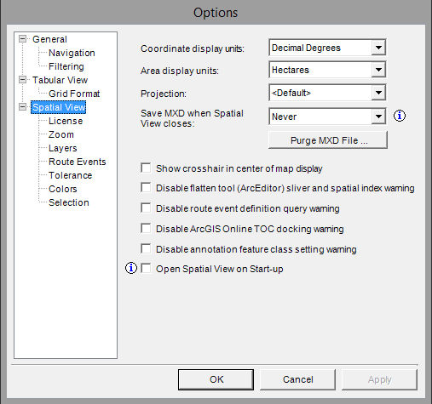

- Click Layers under Spatial View in the tree on the left
- Click the Purge Local Files button
- Click OK
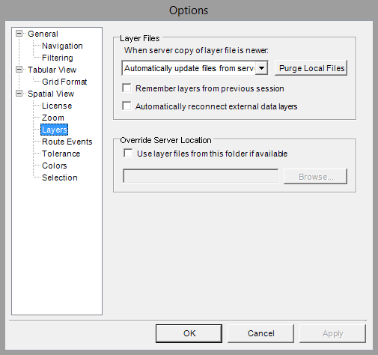

- Re-open your Spatial View and reload layers as needed

